EXPERIMENT 1
TITLE - Write a program to show concept of class in Java
OUTCOME- After executing this program, we will learn how to declare instance variables and methods inside a class, understand the concept of encapsulation and how data and behavior are grouped together within a class.
OBJECTIVE- To understand the concept of classes and objects in Java and how they are used to implement object-oriented programming principles.
THEORY- In Java, Object-Oriented Programming (OOP) is a powerful approach to software design that organizes code into classes and objects. A class serves as a blueprint or template for creating objects. It defines the data and behaviors that characterize a particular type of object.
A class encapsulates two main components:
- Data members (variables): These are attributes or properties that hold the state of an object.
- Methods (functions): These define the actions or behaviors that an object can perform.

Key Points about Classes in Java:
- A class is defined using the class keyword.
- Every Java program must have at least one class, which contains the main() method.
- Classes promote encapsulation — combining data and methods into a single unit.
- They make code modular, reusable, and easy to maintain.
- Multiple objects can be created from the same class, each with its own data.

Properties of Java Classes
- Class is not a real-world entity. It is just a template or blueprint, or a prototype from which objects are created.
- A class itself does not occupy memory for its attributes and methods until an object is instantiated.
- A Class in Java can contain Data members, methods, a Constructor, Nested classes, and interfaces.

Java Objects
Objects are the instances of a class that are created to use the attributes and methods of a class. A typical Java program creates many objects, which as you know, interact by invoking methods. An object consists of:
- State: It is represented by attributes of an object. It also reflects the properties of an object.
- Behavior: It is represented by the methods of an object. It also reflects the response of an object with other objects.
- Identity: It gives a unique name to an object and enables one object to interact with other objects.
CODE-
class Student {
int id;
String n;
public Student (int id, String n) {
this.id = id;
this.n = n;
}
}
public class Main {
public static void main(String[] args) {
Student s1 = new Student(10, "Alice");
System.out.println(s1.id);
System.out.println(s1.n);
}
}
OUTPUT-

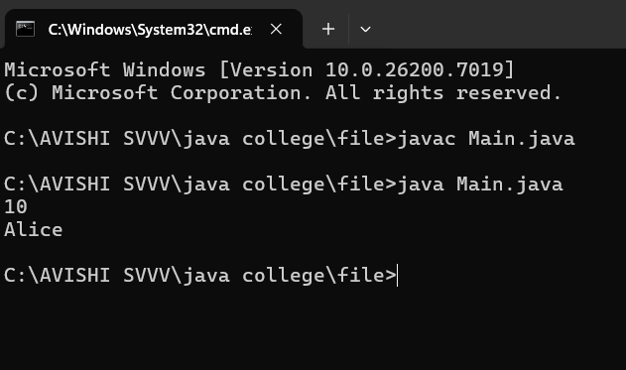
VIVA QUESTION-
1. What is a class in Java?
2. What is an object?
3. What is the difference between class and object?
4. How do you create an object in Java?
5. What is the purpose of the 'new' keyword?

EXPERIMENT 2
TITLE - Write a program showing typecasting
OUTCOME- To understand and demonstrate the concept of typecasting in Java, including both implicit (widening) and explicit (narrowing) conversions between data types.
OBJECTIVE- To understand the concept of typecasting in Java and learn how to convert one data type into another. The aim is to demonstrate both implicit (widening) and explicit (narrowing) type conversions between primitive data types, and to observe how data is handled or lost during these conversions.
THEORY- Typecasting in Java is the process of converting one data type into another. It allows a variable of one type to be treated as a variable of another type. Typecasting is mainly of two types: widening (implicit), where conversion happens automatically from a smaller to a larger data type (like int to double), and narrowing (explicit), where conversion is done manually using the cast operator ( ) from a larger to a smaller data type (like double to int). It is used to make data compatible for operations and method calls between different types.

1. Widening Type Casting
Widening type casting is the process of converting a lower data type to a higher data type. It is also referred to as implicit conversion or casting down. This process is performed automatically and is safe, as there is no risk of data loss. This kind of type conversion and casting in Java happens when:
- The target type is greater than the source type.
- The two data types are compatible.
byte -> short -> char -> int -> long -> float -> double (From left to right: Lower data type to Higher data type)

2. Narrowing Type Casting
Narrowing type casting is the process of reducing a larger data type to a smaller one. Other names for this are casting up or explicit type casting in Java. It does not happen on its own. If we do not do this explicitly, we will get a compile-time error. The narrowing type casting is unsafe because data loss might occur due to the smaller range of allowed values of the lower data type. A cast operator helps in explicit casting.
double -> float -> long -> int -> char -> short -> byte (From left to right: Higher data type to Lower data type)

CODE-
class typecasting{
public static void main(String[] args) {
// Widening (Implicit Typecasting)
System.out.println("Widening Typecasting:");
int num = 100;
System.out.println("Integer value: " + num);
double data=num;
System.out.println("Double value: " + data);
// Narrowing (Explicit Typecasting)
System.out.println("\nNarrowing Typecasting:");
double num1 = 99.99;
int data1 = (int) num;
System.out.println("Double value: " + num1);
System.out.println("Integer value: " + data1);
}
}
OUTPUT-
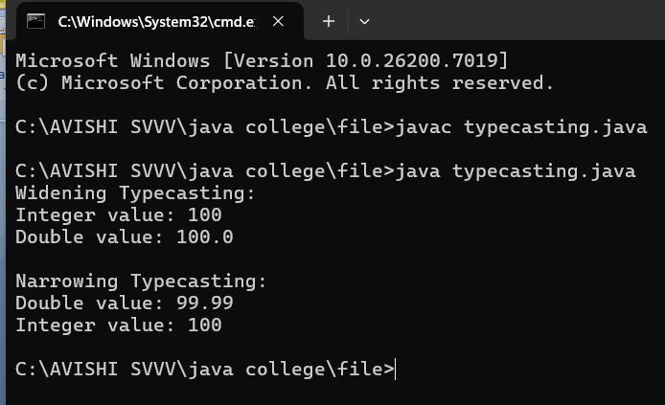
VIVA QUESTION-
1. What is typecasting in Java?
2. What is the difference between widening and narrowing typecasting?
3. Does widening typecasting require explicit conversion?
4. What happens if you convert a double to an int?
5. Can typecasting cause data loss?
6. What are some real-life situations where typecasting is used?

